Data-Driven Journalism

**Experts say rising cesarean deliveries point to procedure being overused**

horizontal line

# 

Creator: Yuri_Arcurs | Credit: Getty Images/iStockphoto

# Doctors say the increase in cesarean birth rates may be indicative of unnecessary c-sections.

A coalition of the nation’s leading experts in obstetrics and gynecology published guidelines that aim to lower the frequency of cesarean section procedures. [The Obstetric Care Consensus](https://www.ncmedsoc.org/wp-content/uploads/2019/02/Paper-ACOG-and-SMFM-Safe-Prev-OF-Primary-Cesarean-Delivery.pdf) is published by both The American College of Obstetrics and Gynecology and the Society for Maternal Fetal Medicine. The literature highlights the “rapid increase” in cesarean section, or c-section, births without an actual decrease in neonatal or maternal mortality.

Made plain, more women are being cut open but women and children aren’t dying any less in the childbirth process.

The Obstetric Care Consensus was published in March of 2014. The consensus challenges doctors to explore non-medical interventions for low-risk pregnancies and look into standardizing fetal-heart monitoring. Although the guidelines were published in 2014, [CDC data](https://www.cdc.gov/nchs/nvss/births.htm) reveals a mostly-unchanged and elevated cesarean birth rate.

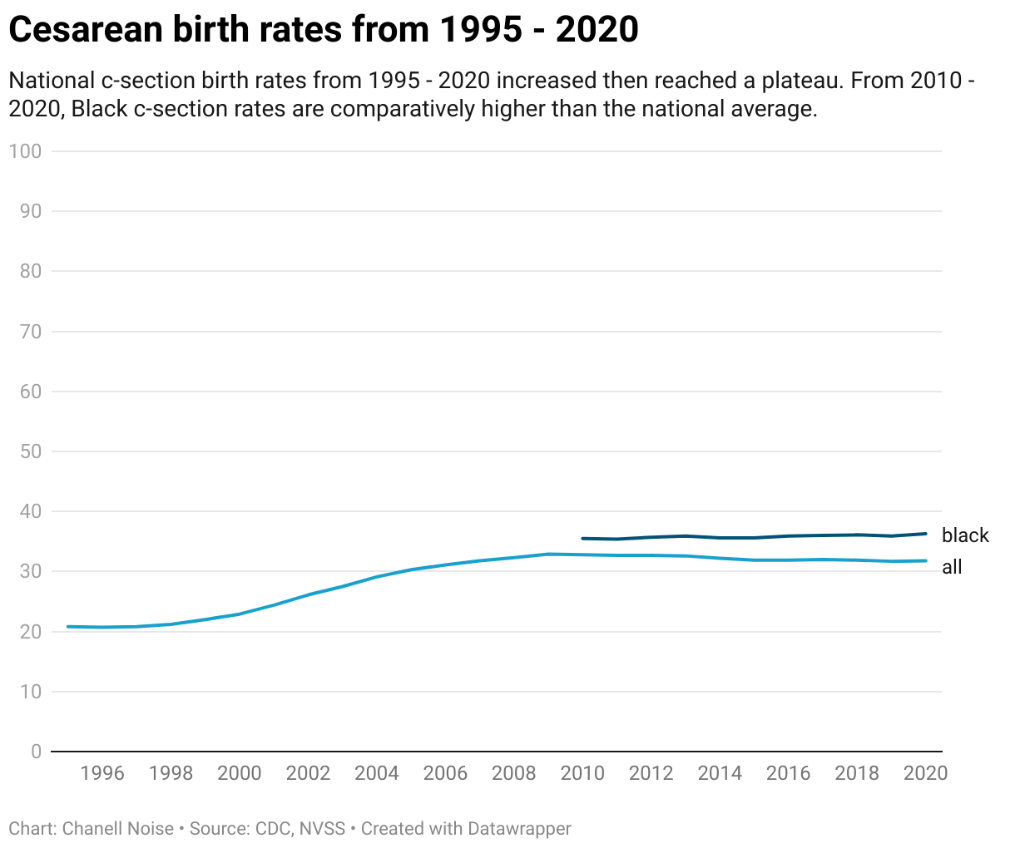

C-sections, in particular, are [the most common operating room procedure](https://healthcostinstitute.org/images/pdfs/HCCI_2020_Childbirth.pdf). Dr. Laura Muangman, a practicing physician at the Reiter, Hill & Johnson women’s clinic explains that c-sections do save lives. “ … a c-section can be the best mode of delivery. If a patient develops an infection or if the baby’s heart rate drops too low- thats an emergency,” she says. “In a cesarean section surgery or c-section is a procedure where one or more babies are delivered through an incision in the birthing patient’s abdomen,” Dr. Muangman explains. “Mom, me, nurses and usually one family member are all in scrubs. Mom is behind a curtain, numb from the waist down during the procedure. When all goes well, we still hand the baby to mom and dad, just like with a vaginal birth,” she said.

Dr. Muangman hammered home that c-sections are absolutely critical. “They save lives and in many high-risk pregnancies and informed patients know that surgery is an option when going into labor.”

Dr. Vincenzo Berghella, then president of the SMFM, co-authored The Obstetric Care Consensus and [helped develop the recommendations in 2014.](https://www.acog.org/news/news-releases/2014/02/nations-obgyns-take-aim-at-preventing-cesareans) He echoed the need for doctors to balance the risks and benefits of c-sections; “...for some clinical conditions, cesarean is the best mode of delivery,” he said. “But for most pregnancies that are low-risk, cesarean delivery may pose greater risk than vaginal delivery, especially risks related to future pregnancies,” he said.

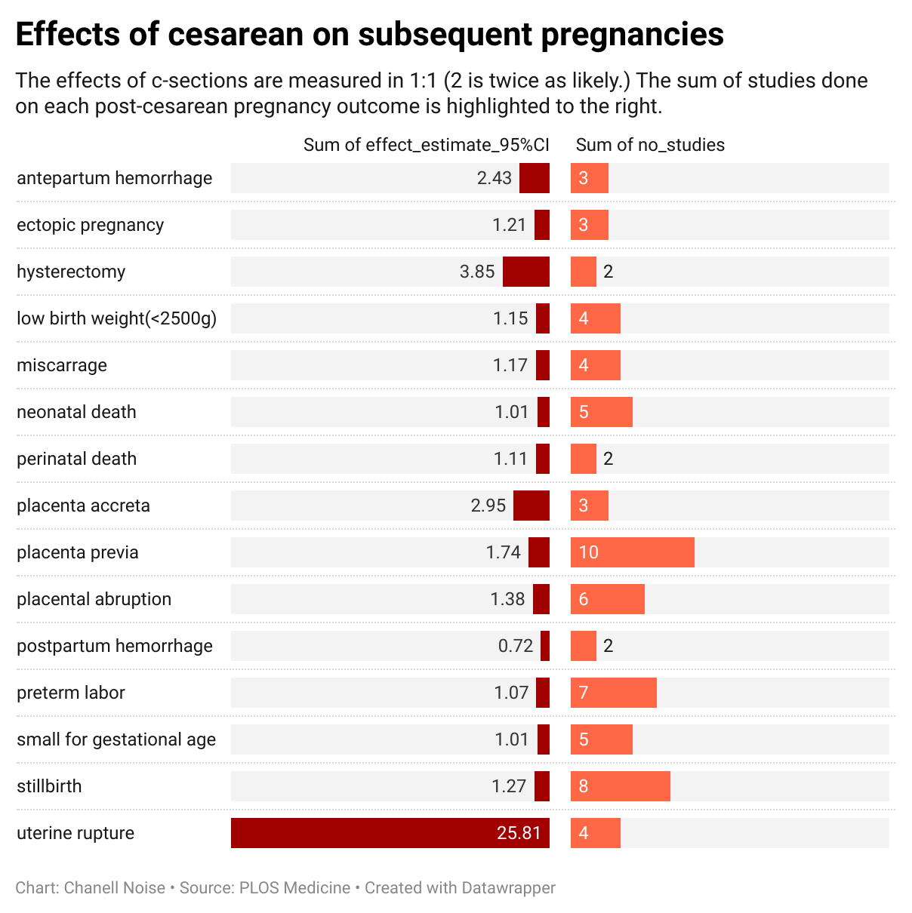

[A series of published studies](https://www.thelancet.com/series/caesarean-section) look at the link between c-sections and negative birth outcomes. Postpartum patients report a spectrum of issues, from [pelvic pain to fecal incontinence.](https://journals.plos.org/plosmedicine/article?id=10.1371/journal.pmed.1002494)

Lynnell Brown, a mother of two from Beaumont, TX, shared how her c-section left scarred tissue and negatively affected her mental disposition.

She said that her first c-section caught her off guard. “After having one c-section, I already knew I was going to have another. I didn’t think the pushing out route was right for me after the first one,” she said. Her doctors agreed. She gave birth to two healthy children, one boy and one girl. But after her second child, she said her postpartum depression and pelvic pain put a damper on that moment in her life.

## C-section rates are higher for women of color, specifically Black women

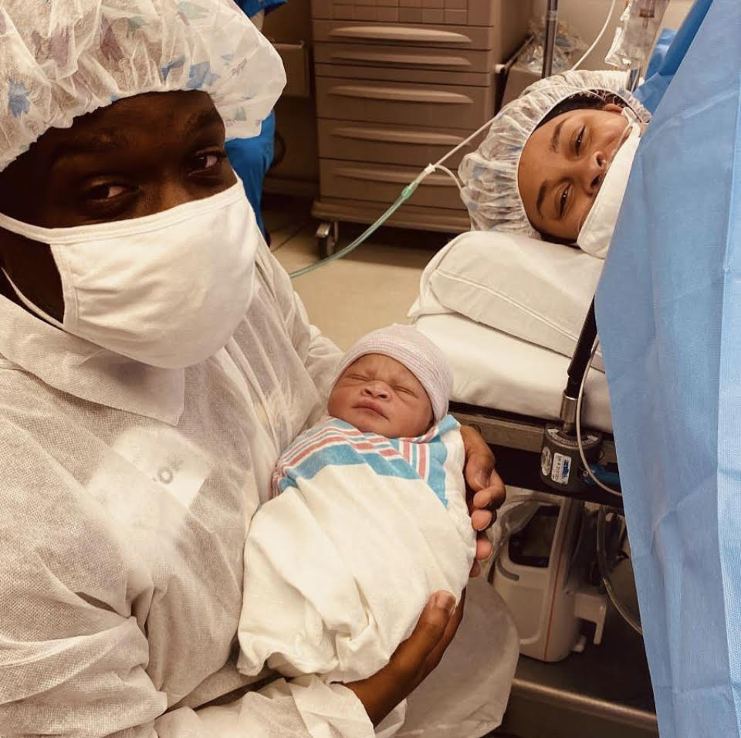

Governing obstetric bodies like ACOG and SMFM note that women of color are overrepresented in cesarean deliveries. [CDC Vital Statistic data shows higher c-section deliveries, both primary and overall, for Black women.](https://www.cdc.gov/nchs/data/nvsr/nvsr70/nvsr70-02-508.pdf) The chart below follows a decade of reported cesarean births in the U.S. from 2010 to 2020. In some years when the national percentage drops, the Black cesarean birth rate increases.

(From left to right: Jerran H, Marley H and Lynnell B in operating room. Lynnell Brown, 2021)

Cesarean birth rates are not the only birth outcome with a clear racial disparity. [Black women are 3 times as likely as their white counterparts to die during childbirth.](https://academic.oup.com/aje/article/152/5/413/149445) There are qualitative, quantitative and of course anecdotal evidence that suggests that Black women are not given quality access to care as often as other patients admitted to the hospital for childbirth.

“Our Black patients will come in and request a Black physician, yes that happens,” Dr. Muangman shared. “A patient should receive the best care regardless of race, class or insurance- none of that should matter. But unfortunately the data points to that being an issue,” she said.

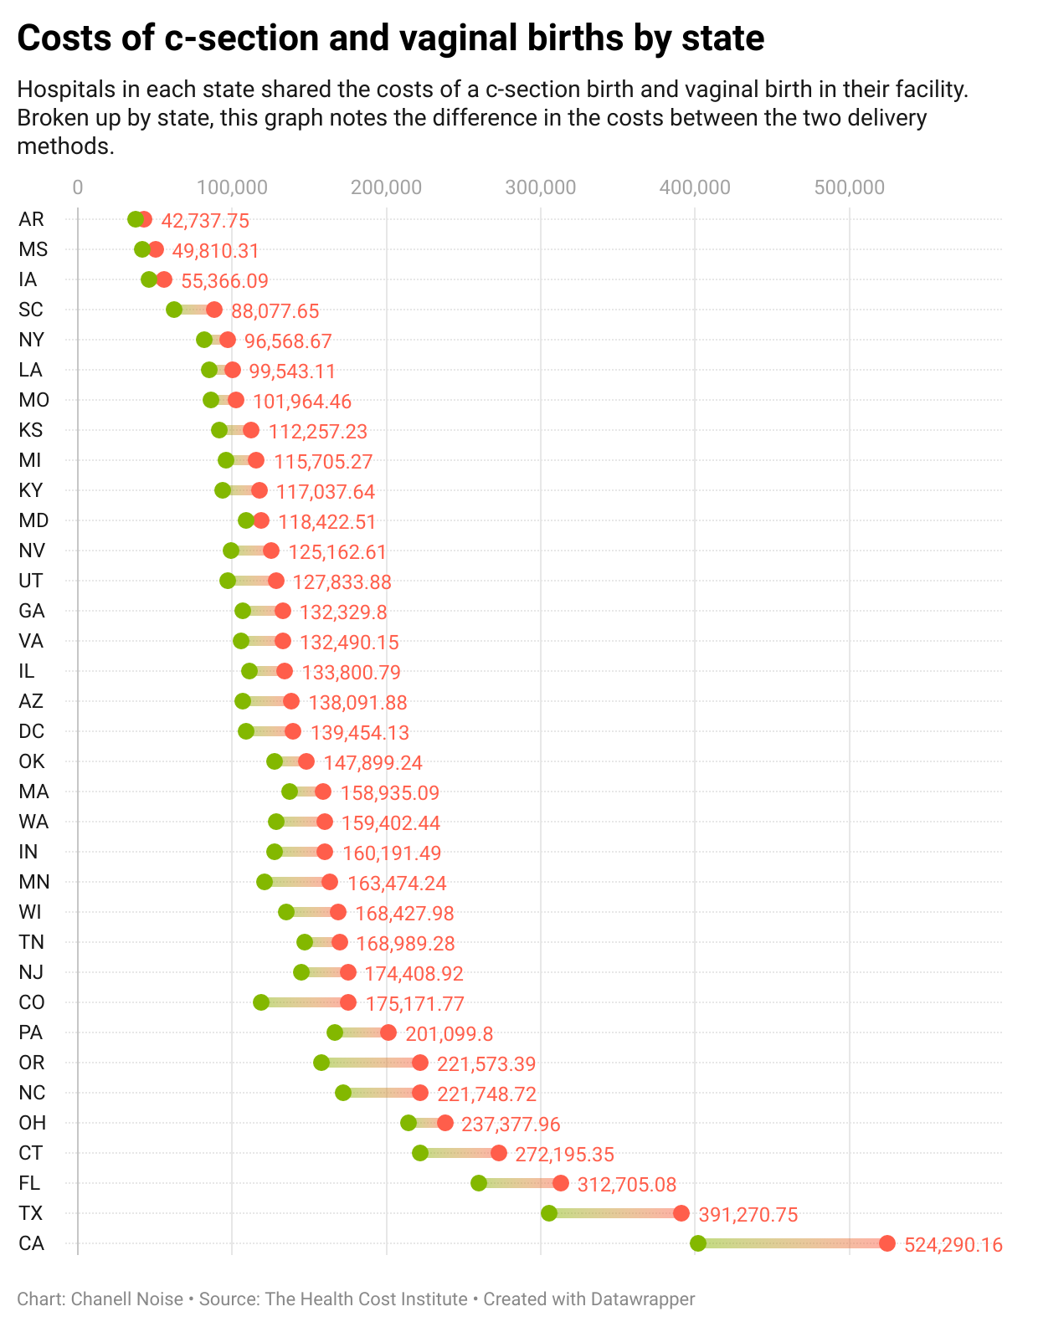

### The WHO sets more recent cesarean guidelines

The World Health Organization published several articles in a 20 year span detailing the rise in cesarean births globally and the risks associated with unnecessary medical interventions during childbirth. In 2021, [The WHO called for women-centered care](https://www.who.int/news/item/16-06-2021-caesarean-section-rates-continue-to-rise-amid-growing-inequalities-in-access) that platformed “a collaborative midwifery-obstetrician model of care, for which care is provided primarily by midwives, with a 24-hour back-up from a dedicated obstetrician.”

Unnecessary c-sections can happen if physicians do not wait long enough throughout the natural length of labor, if cost is considered in the risk/benefit assessment or as the result of a poor birth outcome due to negative racial attitudes.

A goal of a 10% to 15% c-section birth rate was [set by the World Health Organization back in 1985](https://apps.who.int/iris/bitstream/handle/10665/161442/WHO_RHR_15.02_eng.pdf?sequence=1). Again, since that goal was set, c-section rates have ballooned to double the recommended rate. Too many c-sections are happening and [no fewer negative birth outcomes](https://www.thelancet.com/journals/lancet/article/PIIS0140-6736(18)32113-5/fulltext) have come out of this troubling trend.

Governing health bodies, like the WHO, are battling antiquated information on the acceptable amount of time a woman can be in labor. Inducing labor or opting for surgery when patients don't dilate fast enough became common practice until relatively recently.

To combat frivolous medical interventions by way of c-section and double-down on mending the racial gap in birth outcomes, researchers are challenging hospitals to pay doctors equally for either vaginal or cesarean deliveries.

The WHO also calls for a universal classification system; “Currently, there is no standard classification system for cesarean section that would allow the comparison of cesarean section rates across different facilities, cities, countries or regions in a useful and action-oriented manner,” they published. They coined the Robson Classification, a ten-category system, that can help physicians globally monitor their cesarean section-decision-making.

In 2021, the Joint Commission, a non-profit organization that accredits more than 22,000 healthcare orgs and programs, [started publishing c-section rates and data per hospital.](https://www.obhg.com/the-joint-commission-begins-to-report-hospital-c-section-rates/#:~:text=OBHG%20clinicians%20have%20the%20demonstrated,also%20across%20the%20entire%20unit.)

The move is part of a national and international effort to curb scalpel-happy physicians and keep pregnant patients aware.

“If I could do it all over again, I would want a natural birth,” said Brown. “I learned to love my body and I’m grateful I was strong enough to have two beautiful babies. But I don’t want to get cut ever again.”